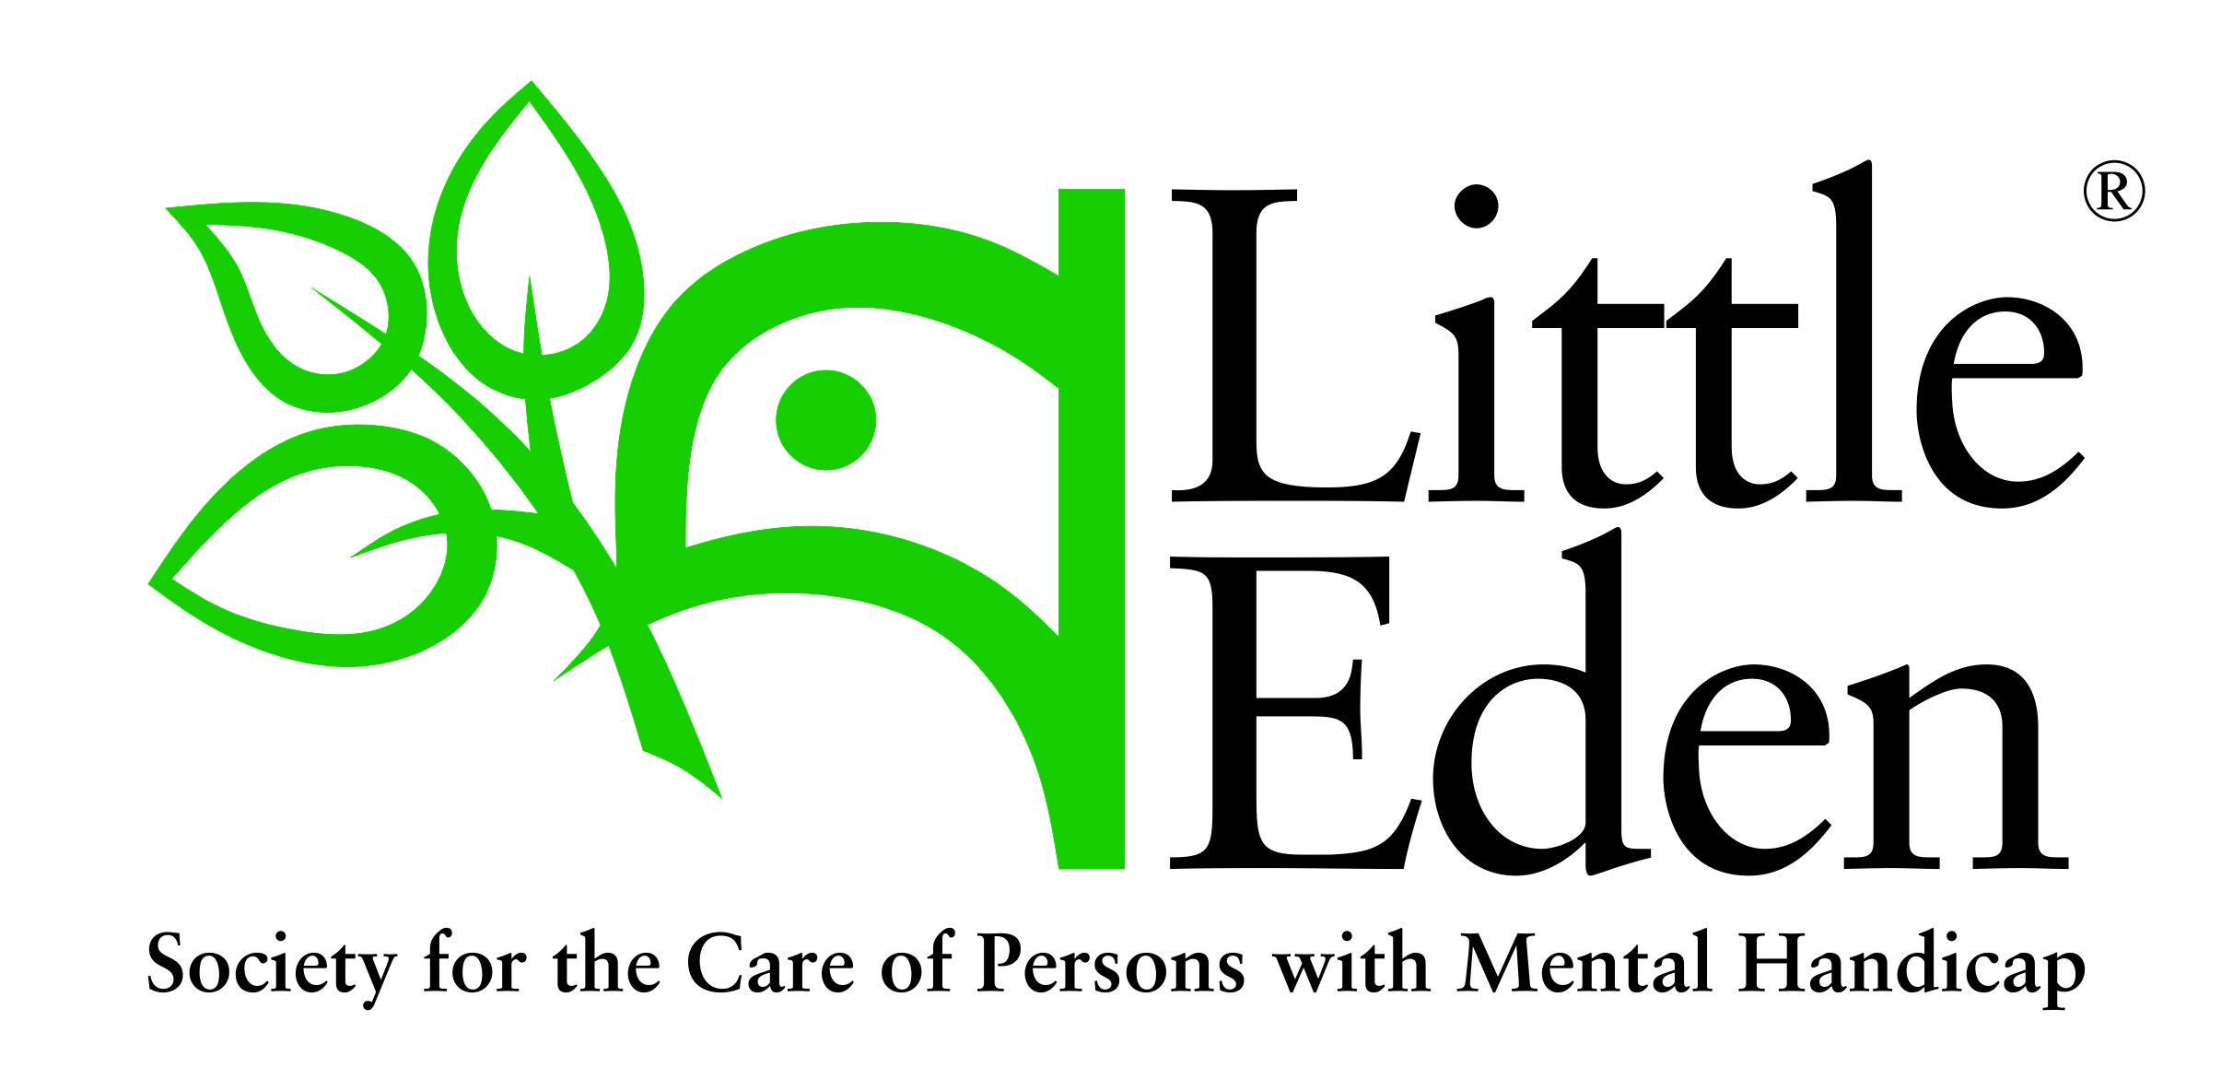
Harvesters of Jesus

(Newsletter 235– 05/04/2019)

The Association of the Harvesters of Jesus was established in order to provide the regular daily spiritual needs of the LITTLE EDEN Society. It is firmly believed that without such support, LITTLE EDEN would wither.

A valuable gift of love

Saint Teresa of Calcutta once said, it’s not how much we give but how much love we put into giving.

Recently I received yet another token of appreciation from one of our residents, Daniella. She requested that I pass it on to a former Fidesco volunteer, Clémence, who had spent two years volunteering her services at LITTLE EDEN before returning home to France. These tokens of appreciation range from photographs, painted flags to knitted jerseys in the colours of the French flag.

Clémence spent the time carrying out various therapeutic stimulation activities with Daniella and her friends at Elvira Rota Village. These included teaching them about how much God loves them and preparing them to receive Jesus for the first time in Holy Communion…what joy she brought them!

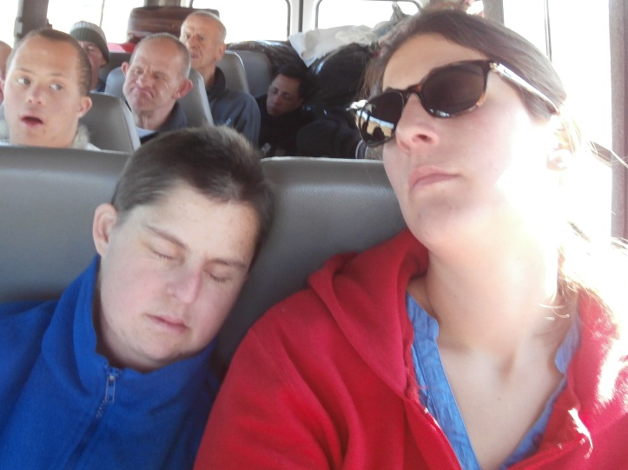
It’s been almost four years since Clémence returned to her country. These ongoing tokens of appreciation from Daniella speak a thousand words to me, including the fact that they confirm the magnitude of the act of giving of oneself that it has on the recipient.

Often, due to intellectual disability, our residents are unable to comprehend fully the meaning of words or perhaps are unable to understand certain acts of giving but without a doubt they are able to understand love when it is given.

If we are to take a leaf out of the book of Daniella and Clémence’s story, it would be that when it comes to giving, elements such as time and compassion add value to the gift and have a lasting impact.
Daniella & Clémence exhausted from a day’s outing
When you give, give with your heart!

N Muthige

Daily prayer for the needs of LITTLE EDEN
Jesus, Great Harvester, who desires the salvation of all mankind, accept the offering of my life and work in assisting You to help garner the fields for the harvest. Teach me compassion, understanding and love for those most in need. Bless our Association; strengthen the bonds of love and charity amongst us, so that with hearts united we may say "Thy kingdom come". Mary, comfort of the afflicted, pray for us.

