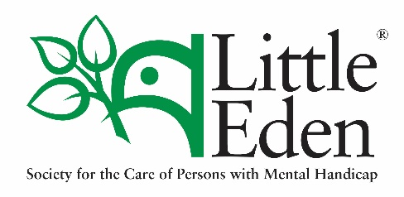
Harvesters of Jesus

(Newsletter 241– 04/10/2019)

The Association of the Harvesters of Jesus was established in order to provide the regular daily spiritual needs of the LITTLE EDEN Society. It is firmly believed that without such support, LITTLE EDEN would wither.

Pay it forward and extend your blessings
Recently LITTLE EDEN hosted the 3rd Annual Danny & Domitilla Hyams Memorial Lecture where the Chief Executive of Standard Bank Wealth, Ms Peggy-Sue Khumalo addressed the audience under the theme Paying it forward.
Often when we hear the term “pay it forward” we think of the receiver as the benefactor, which is true to a certain extent. When one hands over something, someone must be at the receiving end and that someone must feel the benefit or the positive effects of receiving. However, there is a flip side to this coin. The giver can equally benefit from giving.
I am of the belief that we are not meant to hold on to some of the blessings we receive. Some blessings may be harmful or be a disadvantage to us if we decide not to share them. Ms Khumalo shared a story about when the late former SA president, Mr Nelson Mandela gave her the gift of education by arranging a scholarship/bursary for her. Imagine what would have happened if after graduating she decided not to share or use her acquired knowledge? Her gift would have been limited instead of inspiring others to share.
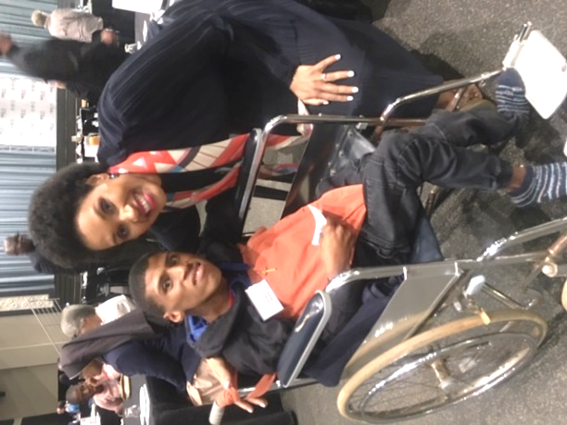
A baby is born with clenched fists and there is a belief that this symbolises God given talents with which we are born. Do you think you would have lived a fulfilled life if you die without having shared your talents with the world? I think not.
This brings to mind the benefits to the community that Danny & Domitilla shared in founding
LITTLE EDEN. Paying it forward doesn’t always mean the act of giving to better someone else but it can be a platform to extend your blessings by sharing them.
LITTLE EDEN resident, Ahmed Moosa with Ms Peggy-Sue Khumalo.
N Muthige
Daily prayer for the needs of LITTLE EDEN Society
Jesus, Great Harvester, who desires the salvation of all mankind, accept the offering of my life and work in assisting You to help garner the fields for the harvest. Teach me compassion, understanding and love for those most in need. Bless our Association; strengthen the bonds of love and charity amongst us, so that with hearts united we may say "Thy kingdom come". Mary, comfort of the afflicted, pray for us.

